matlab experiment 3
PREPARED BY
Tyler Long
In partial fulfillment of the requirements for
ECET 4610
PREPARED BY:
APPROVED BY:
October 12, 2008
SOUTHERN POLYTECHNIC STATE UNIVERSITY
Introduction:

The purpose of this experiment was to show the uses of Matlab in relation to control systems. Part II of this experiment dealt with a mechanical system of variable damping ratios and determined the output response. Part II of this experiment evaluated the performance of the Antenna Azimuth Position Control System on the front cover of the Control Systems text.

Part II:

The following compares the analytical versus Matlab calculated values for D=0.24:

D=0.24 Analytical Values
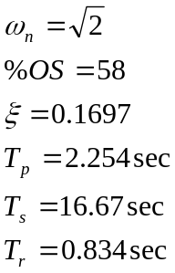

D=0.24 Matlab Values
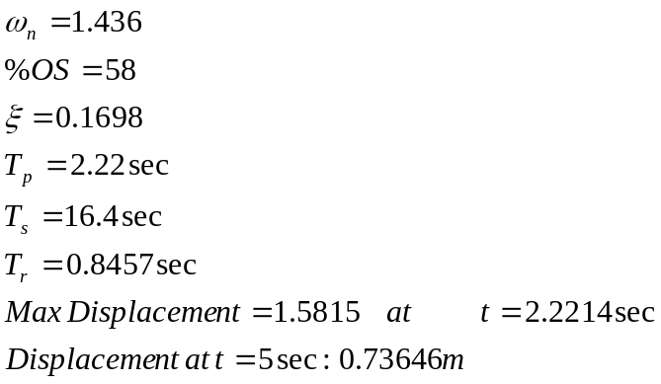

The following compares the analytical versus Matlab calculated values for D=0.48:

D=0.48 Analytical Values
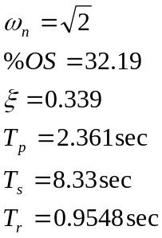

D=0.48 Matlab Values
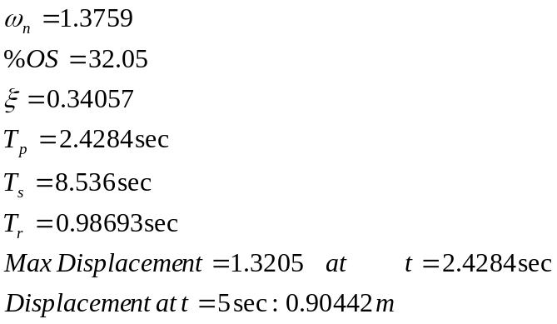

When D=0, the output is considered undamped. The output of the transfer function does not contain a steady state value. It will also have 100 percent overshoot. The frequency of oscillation will be unchanged (still omegan=1.41).

The following is a representation of the outputs of Part II with the inputs as described below:

Inputs:
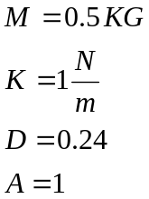
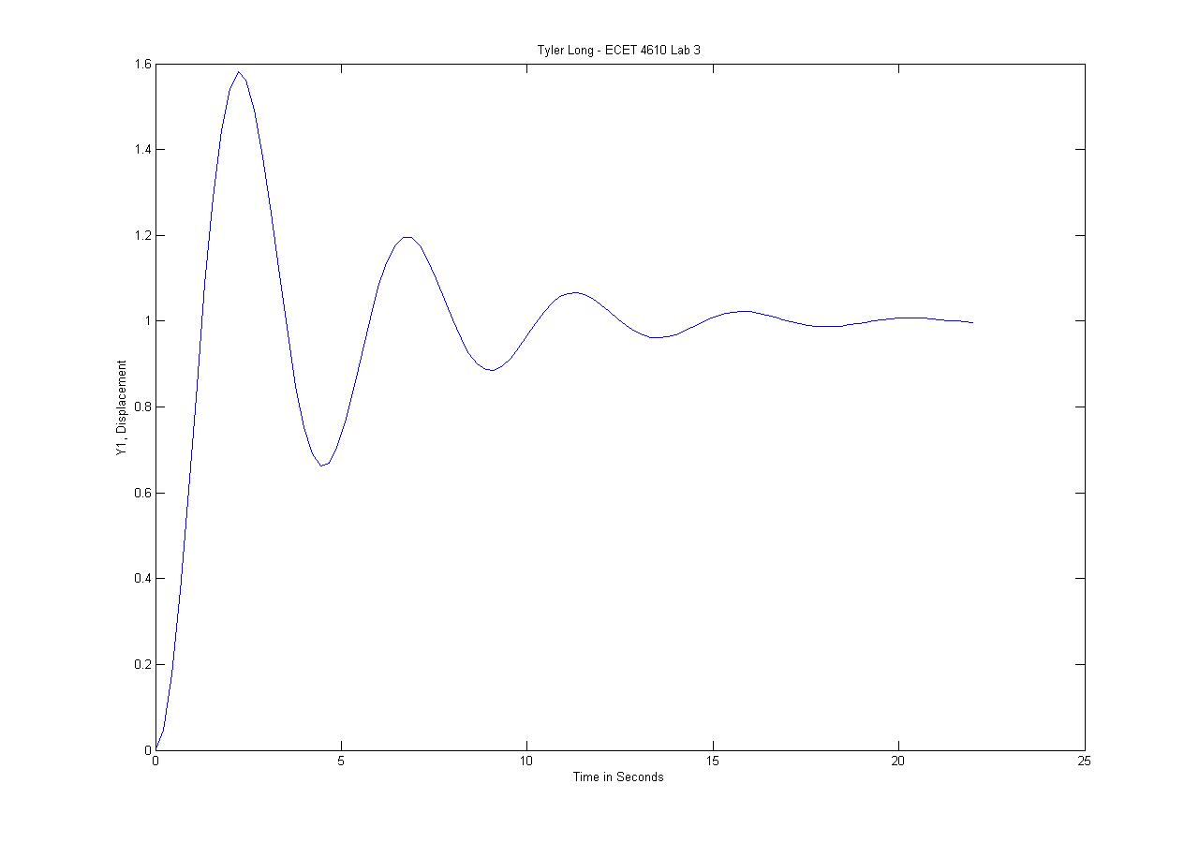
Figure 1: Part II Step Response

Matlab Values for Figure 1:
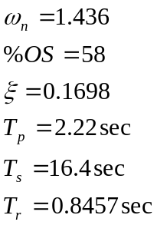
Part III:

The following is a representation of the outputs of Part III with a step function:

Part III transfer function derivation:
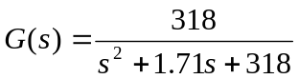

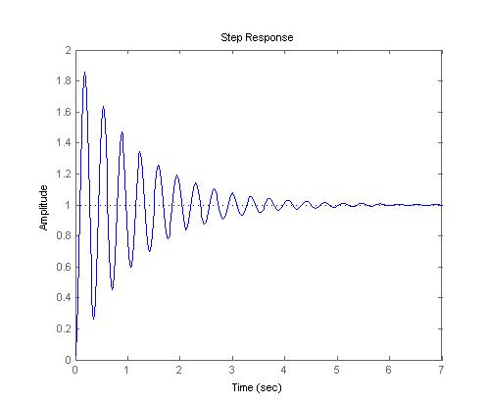
Figure 2: Part III Step Response

Matlab Values for Figure 2:
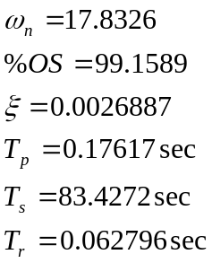

Conclusion:

The program was created such that values were interpolated in between data points in order to extract values from the graph. Since Matlab determines the step of time when performing a step function to a transfer function, the use of interpolation allows the user to find values which were not originally calculated within the scale determined by Matlab.

Array manipulation was key in order to obtain the correct values within this experiment. Some arrays needed to be shortened where values repeated or maximum values were continually exceeded in multiple locations (undamped systems). This method allowed for easier calculation of the rise time.

The use of the “if” statement was integral to the functionality of both parts of this experiment. An error was generated when the user entered values outside of the range of allowed damping coefficients. The “if” statement also allowed the proper equations to be used based on the user’s inputs.

